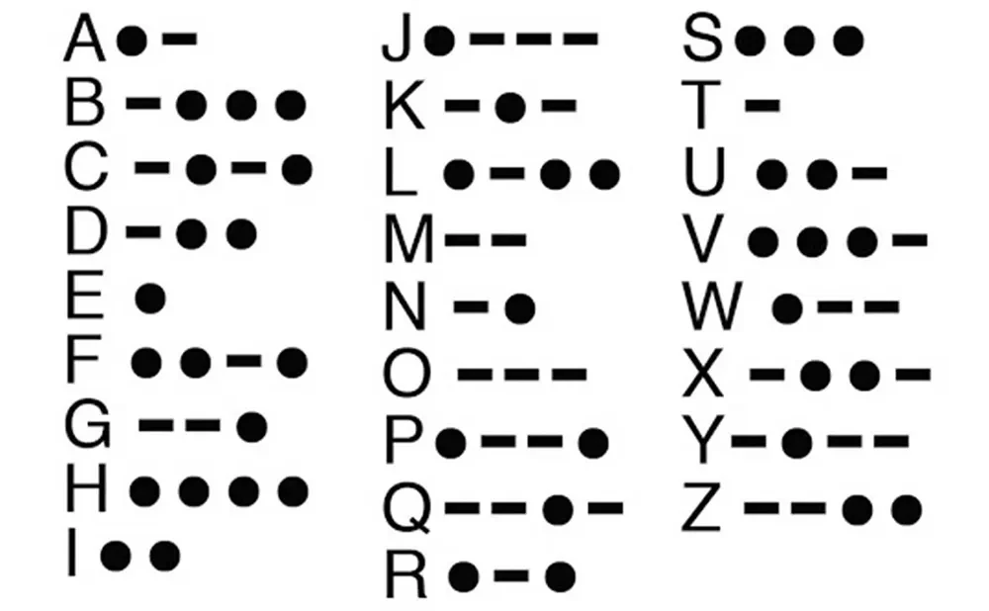  Iambic Morse Keyer and Trainer | Overview  A standalone embedded device that generates accurate iambic Morse code and helps users learn and practice Morse through adjustable speed control, on-screen feedback, and interactive training and decoding modes.  Seth Hibpshman  EENG 163-001

Iambic Morse Keyer and Trainer: Project Proposal
A hands-on embedded systems project focused on designing and programming a standalone iambic Morse code keyer that provides real-time feedback and basic training modes to reinforce timing, input handling, and user interaction fundamentals.

Seth A. Hibpshman
Student of Electrical Engineering
Eastern Washington University
EENG 163: Introduction to Embedded Systems
Final Project Thoughts
March 18, 2026

The cover image is provided by: Connie on retvis.com



Table of Contents
Project Goals & Outcomes 1
Future Improvements 1
Project Limitations 1
Challenges & Solutions 2
Key Resources 2
Project Reflection 2
Assignment Design Feedback 3

Project Goals & Outcomes
The goal of this project was to design and build a functional morse code keyer and trainer using an ESP32-S3 microcontroller running MicroPython. The core objective was to create a device that could key morse code through paddle inputs, decode it in real time, and display output on an OLED screen. This goal was fully met.
Beyond the core requirement, the project grew significantly in scope. A rotary encoder-driven settings menu was implemented with live-adjustable parameters including WPM, volume, keying mode, LED feedback, and decoding toggle. Four distinct keying modes were developed: Iambic A, Iambic B, Ultimatic, and Straight Key. A 4x4 matrix keypad was integrated to support a Keyboard Replay Mode, allowing alphabetic text entry via multi-tap T9 input that is encoded to morse and played back through the buzzer. Additional features included automatic morse decoding displayed on the OLED, a sleep mode with a bouncing logo screensaver, and a typewriter-style boot screen. The final device was also housed in a custom enclosure and custom manufactured Printed Circuit Board.

Future Improvements
Several improvements would strengthen the device in a future revision. The most impactful would be a proper Training Mode with structured exercises, prompting the user with a letter or word and scoring their keyed response. The groundwork for this mode exists in the codebase but the scoring logic was not implemented within the project timeline.
Additionally, the current morse decoding relies entirely on gap timing, which means imprecise keying or slight timing drift can produce incorrect letter breaks. A more robust signal processing approach, such as adaptive timing based on the user's average dit length, would significantly improve decoding accuracy at varying skill levels. Persistent settings storage using non-volatile memory would also be a valuable addition, as all settings currently reset to defaults on power cycle.

Project Limitations
The primary hardware limitation encountered was the refresh rate of the SSD1306 OLED display. At the I2C speeds available on the ESP32-S3 with a software I2C implementation, full screen redraws produced visible flicker during active keying. This was mitigated by minimizing the number of pixels redrawn per update, only clearing and redrawing the regions of the screen that changed rather than calling a full screen clear each time.
Memory was also a consideration on the microcontroller. MicroPython's overhead on the ESP32-S3 leaves a limited heap for application data, which influenced decisions around string handling and buffer management. The morse content string grows unbounded during a session, though in practice the display only ever shows the last 16 characters, so this was an acceptable tradeoff for the project scope.

Challenges & Solutions
The most technically challenging aspect of the project was implementing reliable gap detection for automatic letter and word spacing. Morse code timing is inherently relative, as the gap between two elements depends on the operator's speed, so a fixed threshold in milliseconds would fail at different WPM settings. The solution was to derive all timing thresholds dynamically from the dit duration, which itself is calculated from the live WPM setting. This meant letter breaks, word breaks, and inter-element gaps all scale correctly as the user adjusts speed.
Implementing Iambic B keying mode also required careful state management. Iambic B requires the keyer to send one additional element after both paddles are released, remembering which element was sent last. This was solved by tracking a "both held" flag across loop iterations and firing one extra element on the cycle after release.
The settings menu required significant architectural work to implement cleanly. Making the menu index-agnostic, so that adding or reordering items would not break the logic, involved abstracting menu items into a list of tuples and driving all selection, scrolling, and editing behavior from that single data structure.

Key Resources
The primary software resources used in this project were the MicroPython documentation, the SSD1306 and GFX libraries for OLED rendering, and the official Morse code symbol reference from Wikipedia. Hardware datasheets for the ESP32-S3 were referenced during pin assignment and peripheral configuration. PyCharm and Thonny were used as development environments throughout the project.

Project Reflection
The most satisfying aspect of this project was watching isolated components come together into a cohesive and genuinely usable device. Implementing a feature like Iambic B, which competitive morse operators rely on, and having it work correctly on custom hardware was a meaningful milestone.
The most challenging part, and the least enjoyable in the moment, was debugging timing-related issues. Because so much of the program depends on millisecond-accurate loop execution, any blocking call such as a slow OLED redraw would throw off keying feel and gap detection. Tracking down these interactions required careful instrumentation and rethinking how and when screen updates were triggered.
Overall the project was a strong balance of hardware and software work, and the open-ended scope allowed the device to grow well beyond a minimum viable product.

Assignment Design Feedback
The open-ended nature of the final project assignment was well suited to this type of work. Being able to define the project goal independently allowed the scope to match personal interest, which drove significantly more effort than a prescribed assignment likely would have.
If the assignment were to be redesigned, one suggestion would be to require a brief scoping checkpoint partway through the project timeline. Several features were added late in development that, had they been planned earlier, would have influenced earlier architectural decisions. A midpoint design review would encourage students to think about extensibility before the codebase grows large enough that restructuring becomes costly.

